Task Description #1 – Stack Implementation
Task: Use AI to generate a Stack class with push, pop, peek, and is_empty
methods.
Sample Input Code:
class Stack:
pass
Expected Output:
• A functional stack implementation with all required methods and
docstrings
Prompt: Generate a code for this question and also add a line to print some Output.
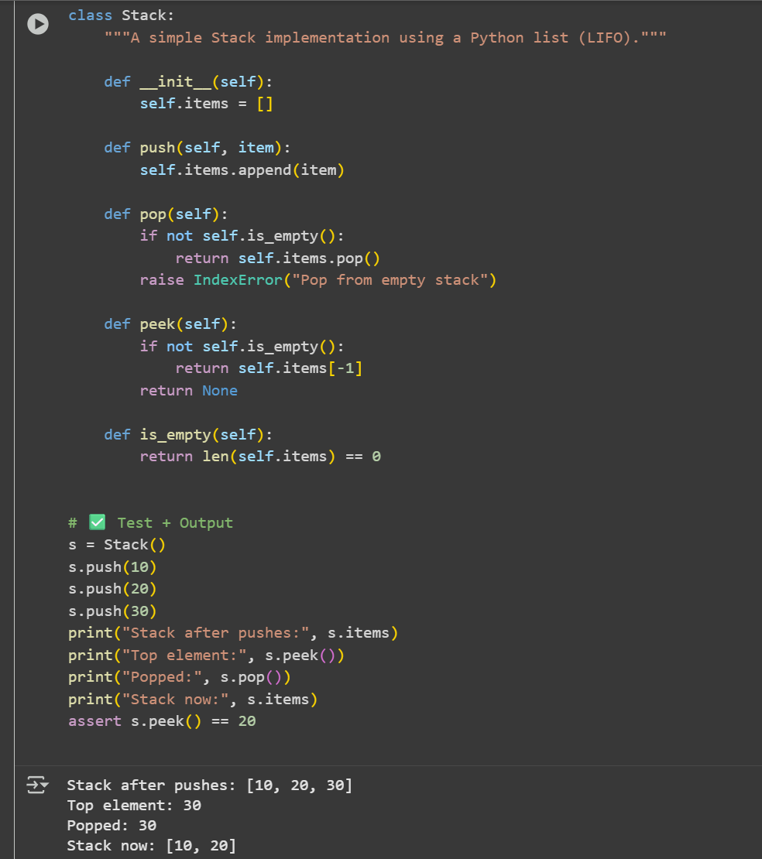
Code and Output:

Observation: In this code we can observe that the code is giving output top element,popped,stack.

Task Description #2 – Queue Implementation
Task: Use AI to implement a Queue using Python lists.
Sample Input Code:
class Queue:
pass
Expected Output:
• FIFO-based queue class with enqueue, dequeue, peek, and size
methods.
Prompt: generate the code for this query and print the output.
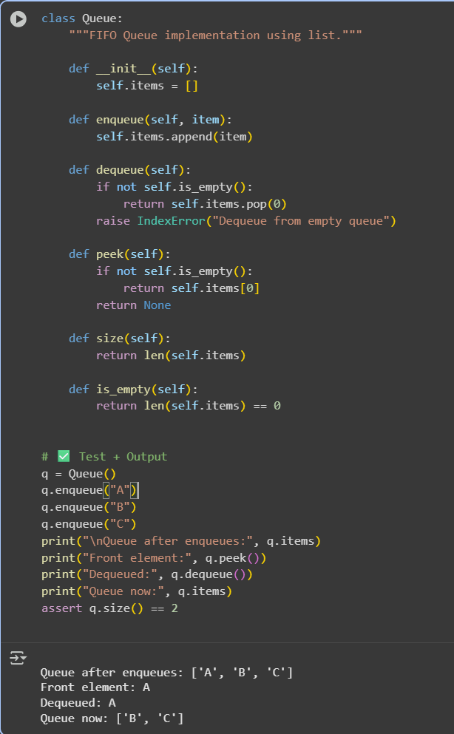
Code and Output:

Observation: In this code we can Observation that the code is giving the output of front element, dequeued , Queue now.

Task Description #3 – Linked List
Task: Use AI to generate a Singly Linked List with insert and display methods.
Sample Input Code:
class Node:
pass
class LinkedList:
pass
Expected Output:
• A working linked list implementation with clear method
documentation.
Code and output:
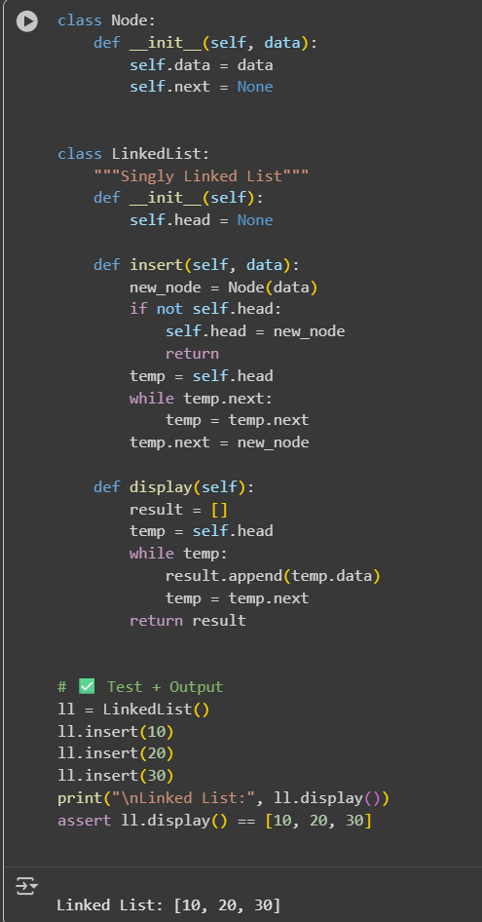
Observation: In this code we can see that the code is linking the list.

Task Description #4 – Binary Search Tree (BST)
Task: Use AI to create a BST with insert and in-order traversal methods.
Sample Input Code:
class BST:
pass
Expected Output:
• BST implementation with recursive insert and traversal methods.
Code and Output:
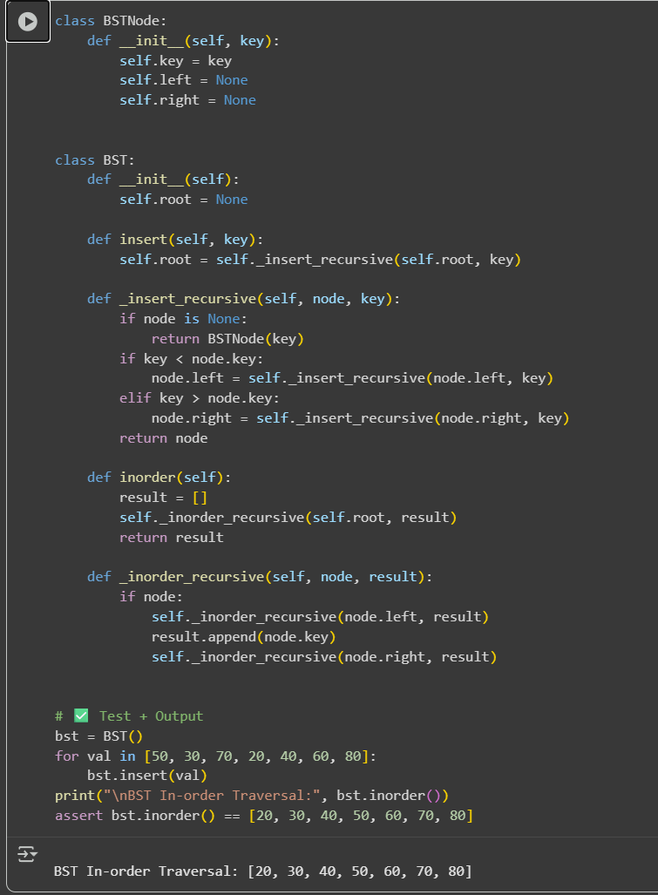
Observation: We can observe that the code is making the list into BST In-order Traversal

